Machines from Wehr against Corona
ROTA technology fills vaccines worldwide. Among them are vaccines from Moderna and Biontech
by JULIA BECKER, SUEDKURIER regional newspaper
Translation from Original in German to English: ROTA
Wehr, [Baden-Württemberg, Germany] - Researchers, doctors, chemical companies and logistics experts - a vast machinery is working this year to make vaccination against the novel corona virus possible. One of the wheels is turning in Wehr: Corona vaccines are currently being filled worldwide on ROTA Verpackungstechnik's equipment: Moderna in France, Biontech/Pfizer in Germany and [...] in Russia.
For employees and management of the special machinery manufacturer, the schedule pressure is a particular challenge: "Normally, we need 12 to 14 months from planning to final acceptance. This year it had to be done within nine months - - that's very challenging," says Managing Director Joachim Delhey. In the middle of the year it became clear that the packaging companies needed more machines, Delhey continues.
Besides the long-standing customer Mibe in Brehna/Saxony-Anhalt. which fills for Biontech/Pfizer, a new customer from Russia also joined the group with [...]. But there were no special requirements for the Corona vaccine: "Filling is so fast that special cooling is not necessary," explains Delhey. It is more important that the systems fit into the respective clean rooms and that safe filling is guaranteed. It is also challenging that the production of the Corona vaccines runs in addition to the daily business and during a pandemic. "Our employees are aware of their responsibility," says Delhey and is pleased to report that so far there has not been a Corona case in the company.
The fact that machines and systems from Wehr are sent all over the world is nothing new for the company. The family business with 125 employees is one of the well-known players in the industry and even one of the market leaders in the ampoule filling sector, Delhey says. "We don't make large-scale plants, but are a specialized provider of flexible solutions," explains managing director Andreas Balke. That is why vaccines are already being filled by the company's machines and lines, Balke adds: the Moderna vaccine in France and the Biontech vaccine at Mibe in Saxony-Anhalt.
Several new lines are now being built. "We are currently manufacturing another line for Mibe. It can fill 18,000 vials per hour," Delhey explains. Delivery and installation is planned for summer 2021. The new vial filling line is already on site in Russia. "For the customer [...] we were able to complete the line within only eight months," Delhey says. Acceptance already took place in September. The vaccine is to be filled there in January.
The company
ROTA Verpackungstechnik was founded in 1995 as a management buyout by Ulrich Delhey together with Jürgen Rebhan and Robert Machwirth.
The company develops and produces machines and systems for washing, sterilising, filling, closing and labelling ampoules, vials, bottles and disposable syringes, primarily for sterile liquid vaccines.
Since 2008, the family-owned company has been managed by second-generation engineer Joachim Delhey as managing partner. Andreas Balke, a graduate engineer, joined as the second managing director at the end of 2019.
Further information about the company on the internet (www.rota.de).
ROTA
Technology for our health. Made in Germany

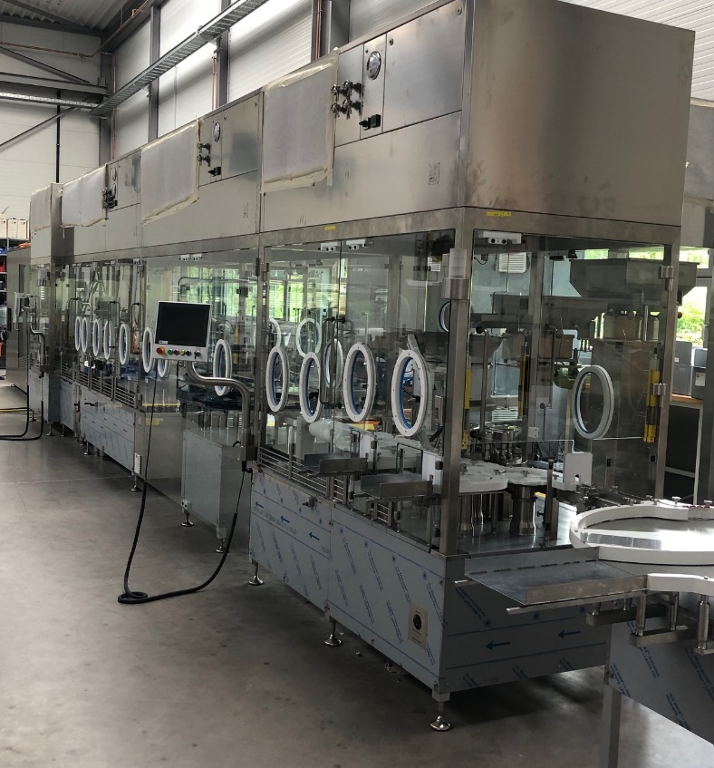
Delivered
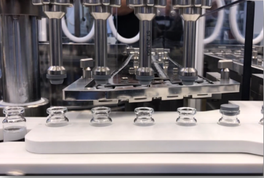
This line was delivered to Russia in the autumn of 2020. Vaccines are scheduled to be filled as
of January 2021.

Filled
The vials filled with vaccine are sealed with a rubber stopper and a crimp cap and can thus be delivered to the vaccination centres.

